**DAILY ONLINE ACTIVITIES SUMMARY**

|  |  |  |  |  |  |  |  |  |
| --- | --- | --- | --- | --- | --- | --- | --- | --- |
| **Date:** | 28/05/2020 | | | | | **Name:** | CHANDANA S | |
| **Sem & Sec** | 4th SEM ‘A’ SEC | | | | | **USN:** | 4AL18CS016 | |
| **Online Test Summary** | | | | | | | | |
| **Subject** | | 1.Microcontroller and Embedded Systems(18CS44)  2.Aadalitha Kannada(18KAK49) | | | | | | |
| **Max. Marks** | | 1.20  2.50 | | **Score** | | | 1.20  2.27 | |
| **Certification Course Summary** | | | | | | | | |
| **Course** | Introduction to R | | | | | | | |
| **Certificate Provider** | | | Great Learning | | **Duration** | | | 2.5 Hours |
| **Coding Challenges** | | | | | | | | |
| **Problem Statement:** 1. (Using C) To find digital root of a number | | | | | | | | |
| **Status:** Completed | | | | | | | | |
| **Uploaded the report in Github** | | | | | YES | | | |
| **If yes Repository name** | | | | | https://github.com/chandushivalingareddy/lockdown-coding | | | |
| **Uploaded the report in slack** | | | | | YES | | | |

**Online Test Details:**

**Microcontroller and Embedded Systems:**

The online test was from module 2 which was about the Introduction to the ARM Instruction set, ARM programming using Assembly language. There were 20 questions and the duration was 40 minutes. The questions were optimal and were easy. The score that I got in the test is 20/20.

**Snapshot:**

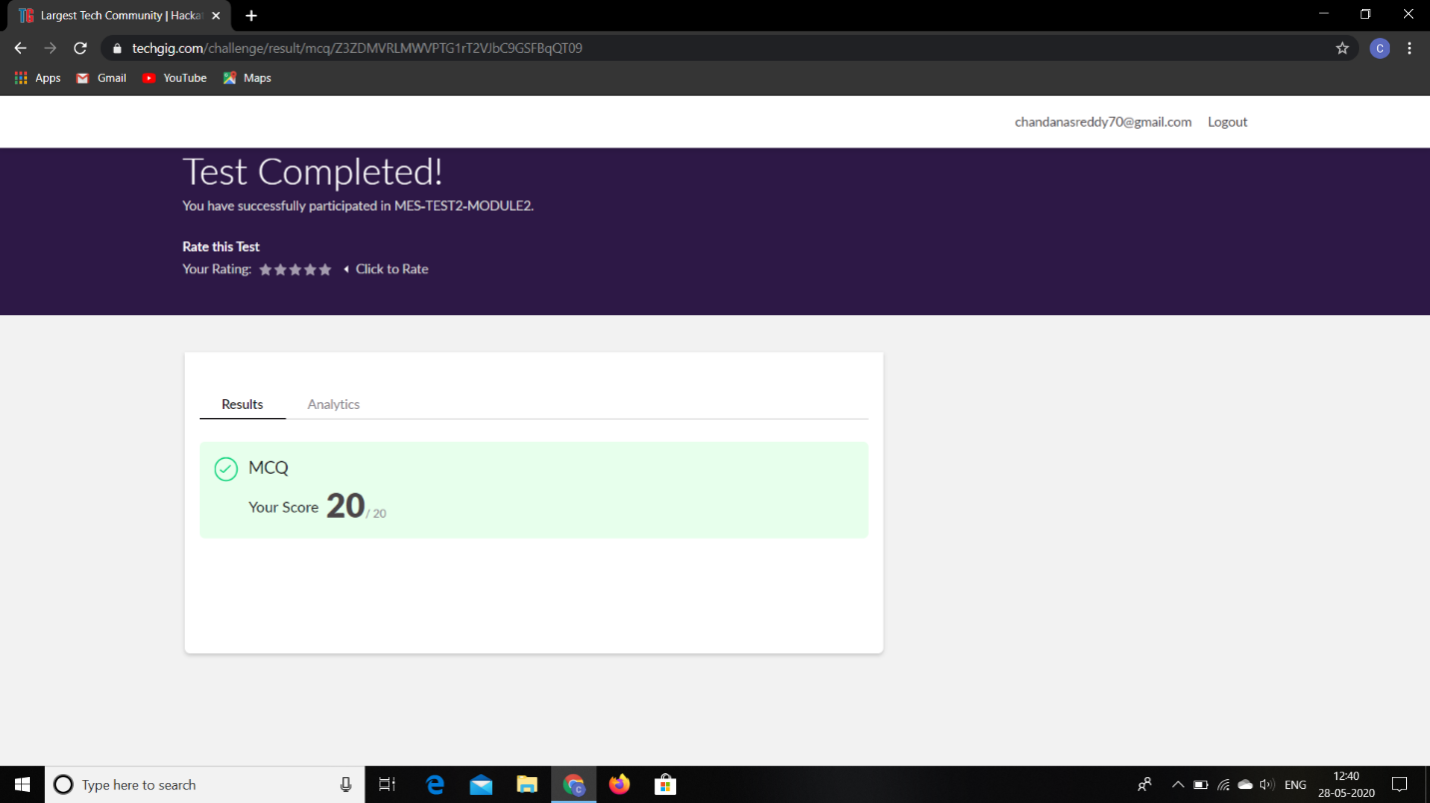

**Aadalitha Kannada:**

The online test was from 10 chapters. There were 50 questions and the duration was 50 minutes. The questions were optimal and were easy. The score that I got in the test is 27/50.

**Snapshot:**

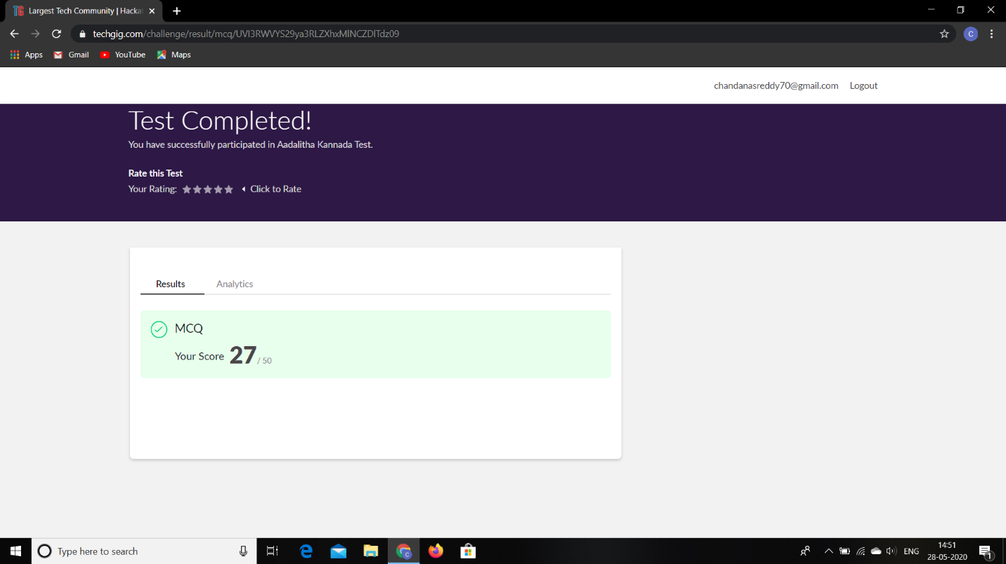

**Certification Course Details:**

**Name of the course**: Introduction to R

**Certificate Provider**: Great Learning

Today I went through the second section of the course that explained about Descriptive Statistics. I have gone through the Introduction to Descriptive Statistics, Measures of Centrality, Measures of Dispersion, Visualizing Data and Data in R.

**Snapshot:**

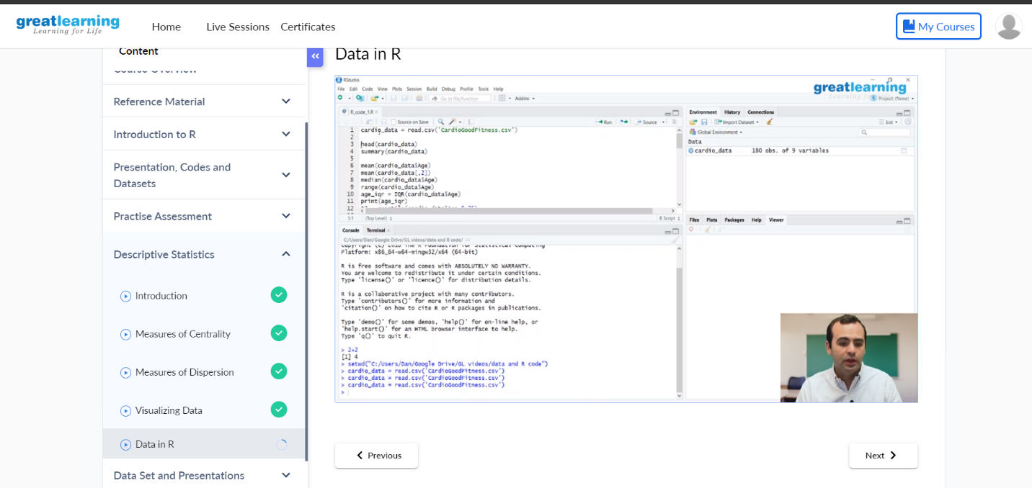

**Online Coding Details:**

Problem 1: (using C language) To find digital root of a number.

**Snapshot:**

